Uber Driver Assistant Project Report

Fare Recommendation Algorithm

Dylan Schwab  
 University of Memphis  
 Memphis, TN  
dschwab@memphis.edu

Truc Nguyen  
 University of Memphis  
 Memphis, TN  
 tlngyen2@memphis.edu

Wenze Wu  
 University of Memphis  
 Memphis, TN  
 wwu2@memphis.edu

1 INTRODUCTION

In this section we will present an overview of the problem, and our approach to solving it.

**1.1 Problem**

Uber (and similar ride share platforms) drivers make their money by picking up passengers and delivering them to their destinations. These platforms do not centrally route their drivers; they allow drivers to choose which passengers to pick up based on their pick-up and drop-off locations. Would it be possible to mine the data from past Uber rides to create a recommendation algorithm which will choose the rides and passengers most likely to maximize the income of an Uber driver? This is the problem that we hope to solve with this project.

**1.2 Approach**

An Uber driver’s income is complicated. A complete accounting would have to include fees, tips, surcharges, surge-pricing, vehicle maintenance and fuel costs. However, for the scope of this project, we will simplify things: An Uber driver makes money when a passenger is in their vehicle. To maximize a driver’s income, we will minimize the time that they spend driving without a passenger.

One way to maximize the time a driver spends with a passenger is to choose the longest trips available. However, this is not the only consideration. What happens when a driver accepts a long trip, but it drops off in a secluded area? They might have to drive that entire distance back, before finding any more potential passengers. For this reason, we are also considering historical rideshare data and processing it to show which geographic areas are busiest for pick-ups at any given time of day.

Our algorithm will combine the weighted scores of a trips time and how busy its drop-off location is, ultimately recommending which rides are most likely to minimize the time a driver spends driving without a passenger, thus maximizing their income.

2 IMPLEMENTING THE MODEL

In this section we will discuss how we implemented our approach.

2.1 The Data

For this project, we used rideshare data from 2018 that was provided by the City of Chicago. There was a CVS file from their website that contained more than 240 million individual trips. The dataset includes the trip ID, trip time stamp, pick-up and drop-off community areas, and the length of the trip. Due to the size of this data set and our computation limitations, we manually reduced the data size to 1,005,000 rows of trip information for the working set or training dataset.

Since we wanted to fully study the trip activities in the City of Chicago, we had to use the full three days of trips. After reducing the data, the CVS file included trips from November 1st to November 3rd of 2018, which satisfied the training dataset requirement.

This new data set included data about each ride, including latitude, longitude for the pick-up location and drop-off location, the length of the trip in seconds, and timestamp data for the pick-up and drop-off times.

2.2 Preprocessing the data

In order to make this data useful for our purposes, it needs to be processed. First, the weekday and times are extracted from the pick-up/drop-off timestamp data into their own columns, while dropping any null data and extraneous columns.

KMeans is then used to generate 72 ‘neighborhood’ clusters based on the latitude and longitude data from pick-up locations. Each cluster’s centroid is given a corresponding number which will identify a ‘neighborhood’. A column is added to the dataframe which identifies each trip’s pick-up neighborhood with this number.

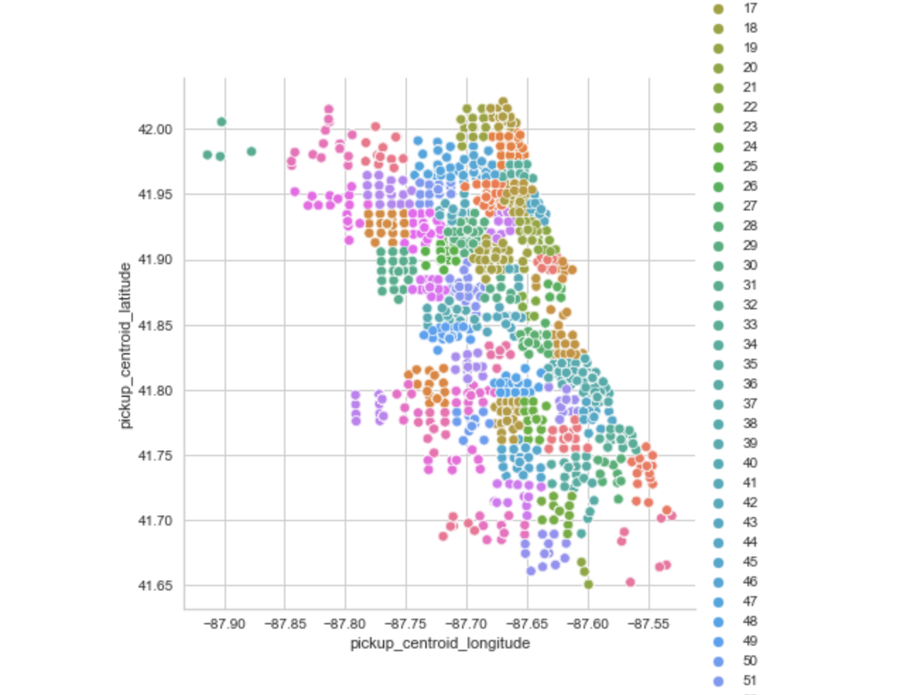

Figure 1: KMeans clusters

Similarly, KDTree is used to identify which of the previously generated neighborhood centroids is closest to a trip’s drop-off location. We use this information to add a drop-off neighborhood to the dataframe.



Figure 2: Cluster centroids plotted over map of Chicago

The day of the week is relevant to which neighborhoods will be busiest (we can imagine that areas with bars and restaurants will be busier on weekends, and areas with office space will be busier on weekdays). Likewise, each trips pick-up time will be relevant as well (our time data was limited to 15-minute increments). The data is then grouped by weekday, time of day, and pick-up neighborhood by size, counting how many pickups there were historically in each neighborhood. Once this data is sorted, we can see which neighborhoods are busiest on which days and at which times.

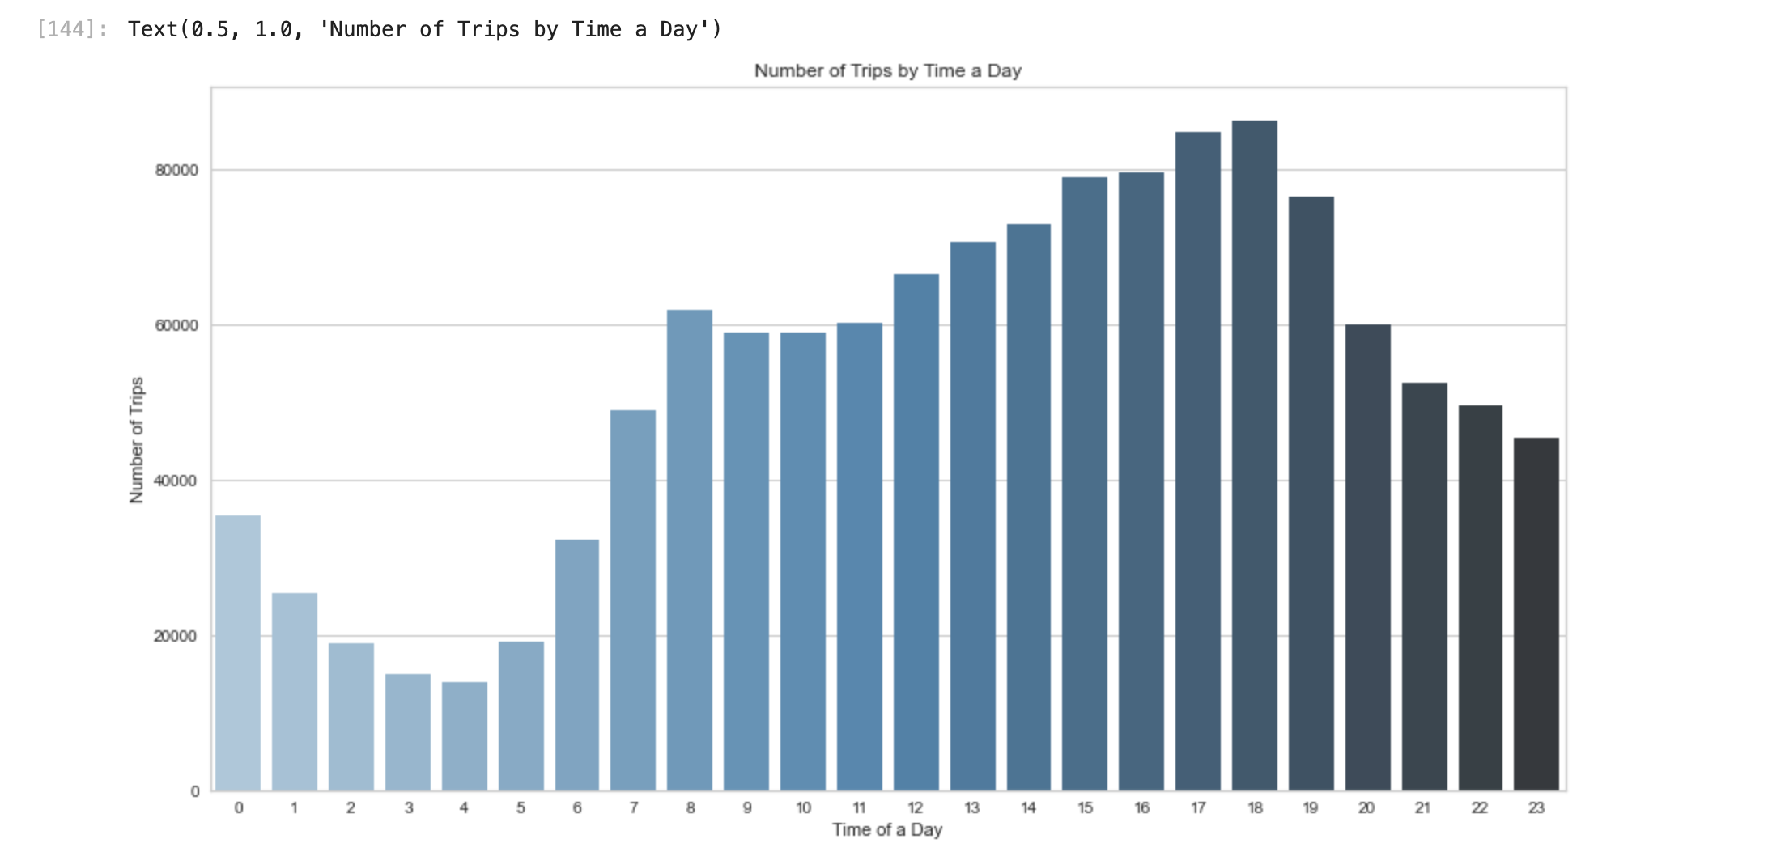

Figure 3: Number of trips by time of day

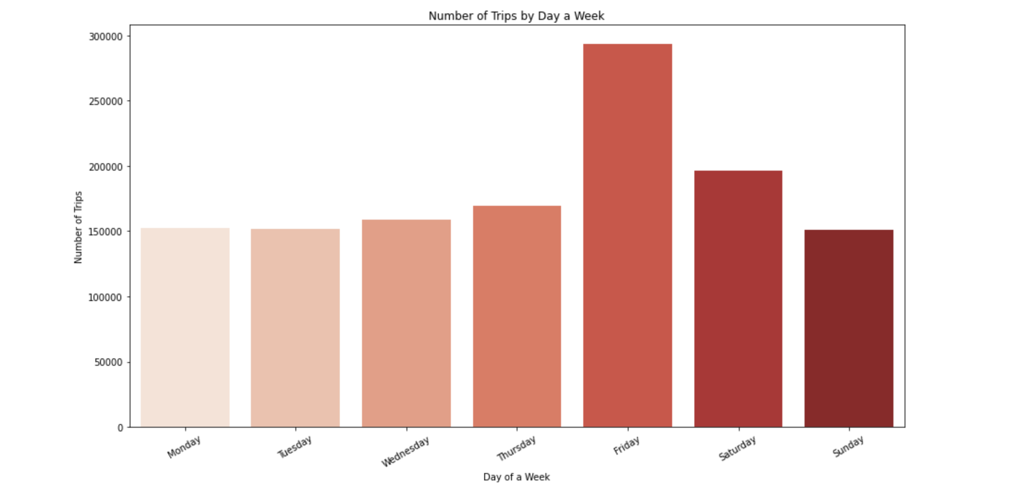

Figure 4: Number of trips by day of week

For example, with this data, we can see that the neighborhood 27 (adjacent to Willis Tower) is historically busiest for pickups at 5:00 pm on Fridays, with 357 pick-ups in one day.

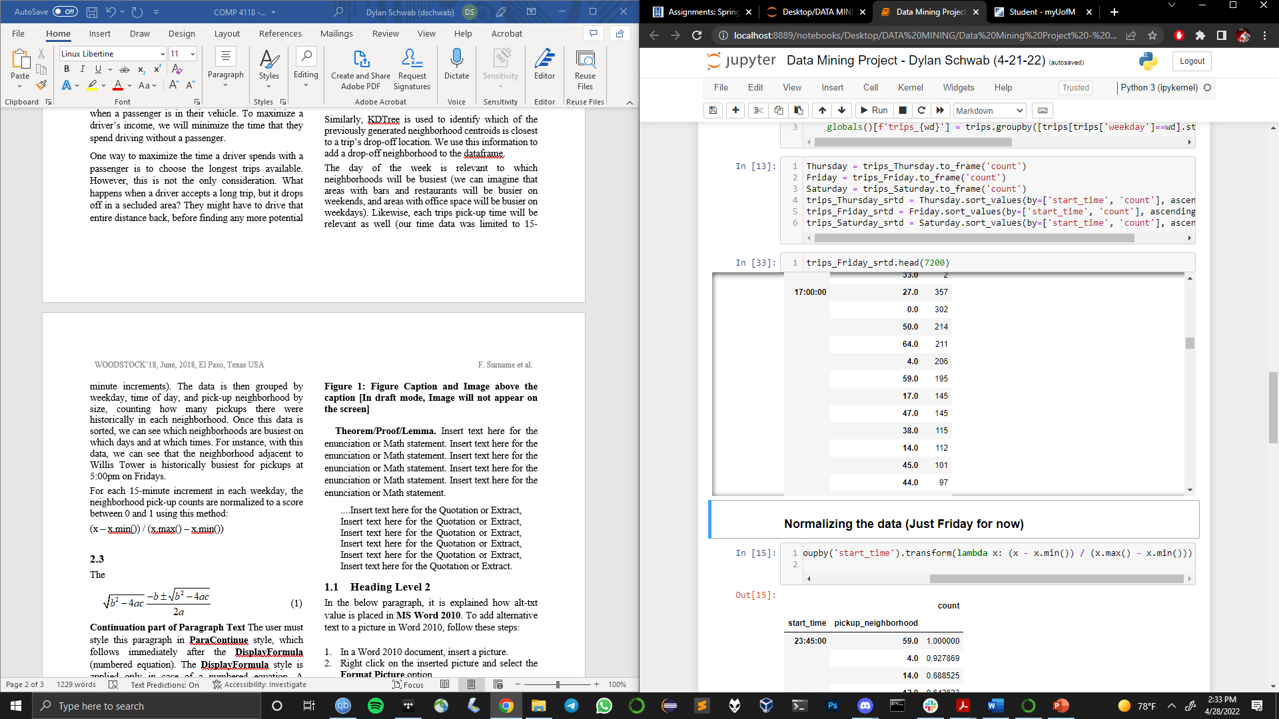

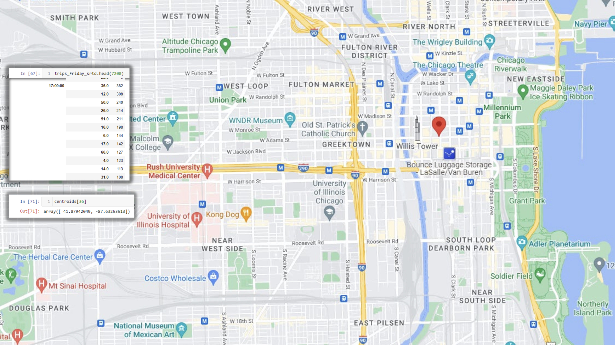

Figure 5: Neighborhood 27 and its corresponding centroid plotted on map of Chicago

After grouping the data, the neighborhood pick-up counts are taken for each 15-minute increment in each weekday and normalized to an ‘activity’ score between 0,1 using:

*(x – x.min()) / (x.max() – x.min())*



Figure 6: Examples of Activity Scores

The neighborhoods with the most pick-ups during each time of day will have the highest activity scores, with the highest being a 1.

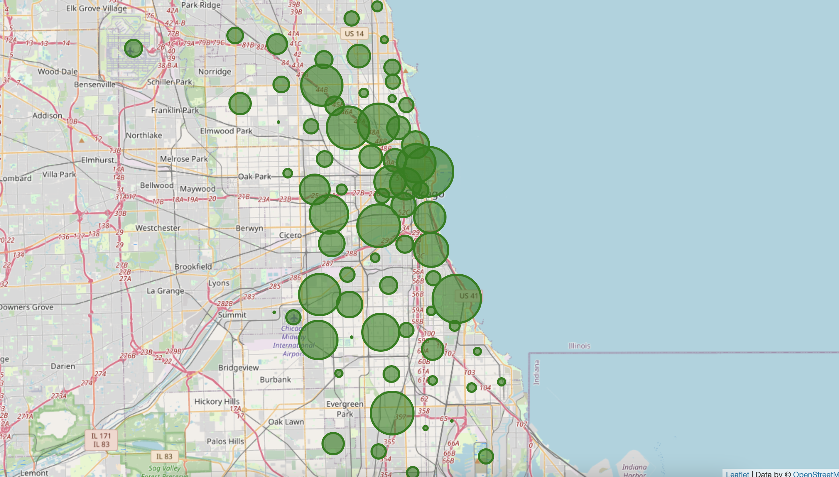

Figure 7: Cluster centroids sized by activity and plotted over map of Chicago

2.3 Recommendation Algorithm

Given a list of candidate rides (potential passengers close to the driver’s current location, which they could choose to pick-up), the recommendation algorithm will note trip time lengths and the drop-off neighborhoods of these rides, finding the relevant activity scores for each neighborhood at their trips’ predicted drop-off time.

The algorithm will take each of the candidate’s trip times and normalize them to a score between 0,1 with the longest time being a 1.

Each candidate trip’s activity score and time score are then weighed and summed:

*Total Score = 2 * Activity Score + Time Score*

The recommendation algorithm returns the candidate trip with the highest score.



Figure 8: Example of Trip Scores

**2.4 Recommendation algorithm code**

def fare_rec(candidates, current):

# take candidate fares and assign them scores based on their dropoff location and the time-length of the trip

candidates['trip_length_score'] = candidates['trip_seconds'].transform(lambda x: (x - x.min()) / (x.max() - x.min()))

for i, row in candidates.iterrows():

candidates.at[i, 'drop_loc_score'] = (friday_nrml.loc[row['end_time'], row['dropoff_neighborhood']][0] * 2)

for i, row in candidates.iterrows():

candidates.at[i, 'total_score'] = (row['drop_loc_score'] + row['trip_length_score'])

next_fare = candidates.iloc[candidates['total_score'].idxmax()]

return next_fare, candidates

3 FINAL THOUGHTS

In this section, we will discuss the outcomes and limitations of our approach.

**3.1 Outcomes**

Our algorithm works for choosing the candidate ride with the longest trip time that will terminate in the neighborhood most historically likely to be busy for subsequent pick-ups. We chose to weigh the activity score of a trips drop-off location twice as highly as the trip time, hoping that this would reduce the amount of time a driver would spend searching for new passengers after a pick-up.

Using our approach, most of the computation happens in preprocessing, which allows our algorithm to function extremely quickly when given a list of candidate rides. With enough computation power, this model could be trained on the full 240 million row data set provided by the Chicago Transit Authority.

**3.2 Limitations**

The algorithm works in so far as it does what we designed it to. However, this is an incomplete look at the complex ecosystem of ridesharing platforms. Our algorithm has many limitations on its real-world efficacy.

First, our algorithm is focused on one single driver who is trying to compete directly with other drivers for the most profitable fares. It does not take into consideration how much competition there might be for valuable fares if multiple drivers attempted to employ this algorithm.

Also, as we discussed earlier, an Uber driver’s income is not exclusively tied to trip times. A more sophisticated algorithm would include fuel costs, surge prices, the socio-economic demographics of neighborhoods (to attempt to predict average tip amounts), and the average star-rating of passengers.

Even if our algorithm functioned perfectly, there is no guarantee that historical data will accurately predict current trends. For example, any data that was generated during the 2021 might not accurately predict the behavior of current commuters because so many people were working remotely during the pandemic.

**3.3 Conclusion**

While this was an interesting solution to implement, it might be more difficult to

SOURCE DATA

[1] https://data.cityofchicago.org/Transportation/Transportation-Network-Providers-Trips/m6dm-c72p

Conference Name:ACM Woodstock conference

Conference Short Name:WOODSTOCK’18

Conference Location:El Paso, Texas USA

ISBN:978-1-4503-0000-0/18/06

Year:2018

Date:June

Copyright Year:2018

Copyright Statement:rightsretained

DOI:10.1145/1234567890

RRH: F. Surname et al.

Price:$15.00